第五章 语言运用模块

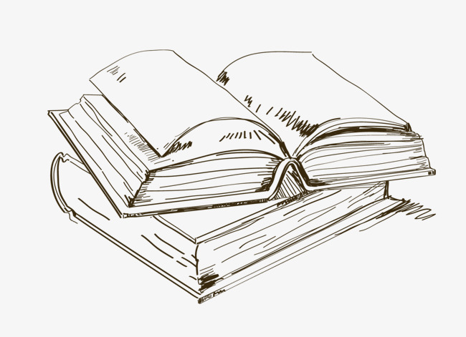

教学目标：
1、知识目标：掌握客舱服务中乘务英语语言运用的基本内容。
2、能力目标：提高客舱服务中英语语言运用的能力。
3、德育目标：帮助学生改善语言沟通技巧，使学生在服务中得心应手。

初 级 篇
第一节 基础知识
（一）广播的基本要求
①广播员在进行客舱广播前，必须熟悉中英文广播词的内容。
②汉语广播时，必须使用标准的普通话进行广播。
③英语广播时，必须使用标准的英语进行广播。
④使用广播器时，与广播器保持适当的距离，避免忽远忽近，影响广播质量。
⑤正确地控制语音、语速、语气、语调。
语音：吐字清晰，字音准确，正确处理轻、重音，恰当地进行停顿。
语速：语速恰当，气息平稳，避免爆破音。
语气：不同的播音内容采用不同的恰当的语气和情绪进行广播，语意连贯，情真意切。
语调：语调起伏平稳完整，在广播重点信息，如航线、时间、地点、高度、温度等信息时，注意适当停顿，吐字清晰。

（二）广播器的使用方法
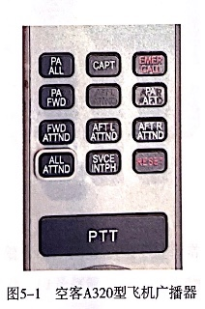
①空客A320型飞机广播器（如图5-1所示）的使用方法。
对整个客舱进行广播：
A.取下广播器。
B.按下“PA ALL”键。
C.按住“PTT”(即PUSH TO TALK)键，嘴巴距离话筒适当的距离进行广播。
D.广播完毕后按下“RESET”键，挂好广播器。
注意:广播过程中，始终按住“PTT”键。

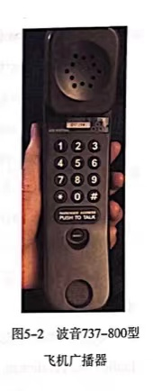
②波音737-800型飞机广播器(如图5-2所示)的使用方法。
对整个客舱进行广播:
A取下广播器。
B按下“8”键。
C按住“PUSH TO TALK”键，嘴巴距离话筒适当的距离进行广播。
D广播完毕后，按下“RESET”键，挂好广播器。
注意:广播过程中，始终按住“PUSH TO TALK”键。

第二节 广播词
- 欢迎词广播
女士们，先生们:(早上/下午/晚上)好!
欢迎您乘坐____航班，您的座位号码在行李架下方。请将您所有的手提行李存放在行李架上或您前面的座椅下方。
找到座位的旅客请您尽快入座，以方便后面的旅客登机。
谢谢您的配合。
Good morning/afternoon/evening, ladies and gentlemen
We are honored^{①} to welcome you aboard ____. Your seat number is indicated on the edge of the overhead bins^{②}.
Stow all your carry-on luggage^{③} securely ^{④}in the overhead bins or under the seat in front of you. Please take your assigned^{⑤} seats as quickly as possible^{⑥} and leave the aisle^{⑦} clear for others.
We appreciate^{⑧} your cooperation^{⑨}. Thank you.
释义:
- honored[ˈɒnəd] v.尊敬;尊重;接受;给予……的光荣
② overhead bins 头顶行李架
③ carry-on luggage 随身携带的行李
④ securely [sɪ'kjʊəlɪ] adv. 牢固地；安心地
⑤ assigned [ə'saınd] v. 分配（某物）；指定；指派
⑥ as quickly as possible 尽快；尽可能快
⑦ aisle[ail] n. 走道，过道
⑧appreciate [ə'pri:fiert] v. 感激；感谢
⑨cooperation [kəu,ppə'reifn] n. 合作；协作；协助；配合
（二）致谢广播
女士们、先生们：
我们全体机组成员对您在旅途中给予的支持和帮助，表示最诚挚的感谢。
Ladies and gentlemen,
On behalf^{①} of the entire^{②} crew, we would like to thank you for your support and cooperation during the flight.
Thank you.
释义：
①on behalf of 代表·····,作为······的代言人
②entire [In'tarə(r)] adj. 全部的
（三）颠簸广播
女士们、先生们：
飞机受到气流影响正在颠簸，请您回到座位上坐好并系好安全带。请不要在客舱内来回走动，带小孩的旅客请照顾好您的孩子并且确保他们系好安全带。
为了您的安全，在颠簸期间洗手间暂停使用。正在使用洗手间的旅客请您抓好
扶手。
谢谢。
Ladies and gentlemen,
Because of turbulence^{①}, please return to your seats and fasten your seatbelt. Do not walk around in the cabin. Please take care of your children and make sure their seatbelt are securely fastened.
For your safety, lavatories^{②} should not be used at this time. Passengers in the lavatories should hold the handle firmly^{③}.
Thank you for your cooperation.
释义：
①turbulence ['tз:bjələns] n. 骚乱；动乱；动荡；混乱；（空气和水的）湍流，涡
流，紊流
②lavatories ['lævətəriz] n.厕所；卫生间；洗手间；盥洗室；公共厕所（或卫生
间、洗手间、盥洗室）
③firmly['f3:mli] adv.坚定地；坚固地

第三节 情景对话
常规客舱服务情景对话：
对话A:引导入座
乘务员：早上／下午／晚上好，欢迎登机。
旅客：早上／下午／晚上好，请问我的座位在哪里？
乘务员：请出示您的登机牌。
旅客：给您。
乘务员：您的座位号是14A,座位号在行李架下方，请您走这边。
旅客：谢谢。
乘务员：不用谢。
Dialogue A: direct to the assigned seat
FA: Good morning/afternoon/evening. Welcome aboard.
PAX: Good morning/afternoon/evening. Can you tell me where my seat is?
FA: May I see your boarding pass^{①}, please?
PAX: Here you are.
FA: Your seat number is 14A.The seat number is indicated on the edge of the overhead bins. This way please.
PAX: Thank you.
FA: You are welcome.
释义：
① boarding pass(旅客）登机牌。
对话B:行李安排（如图5-3所示）
旅客：您好，打扰一下。我的行李很重，请问您能帮我一起安放行李吗？
乘务员：当然可以，让我来帮助您一起把行李放到您头顶上方的行李架上。
旅客：谢谢您。
乘务员：不用谢，这是我应该做的。
Dialogue B: luggage arrangement
PAX: Excuse me. My luggage is very heavy. Could you please help me with it?
FA: Certainly. Let me help you to put your luggage into the overhead compartment.
PAX: Thank you very much.
FA: You're welcome. It's my pleasure.
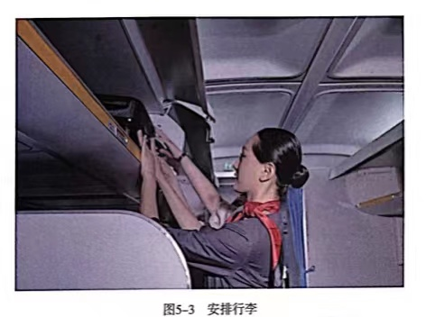
对话C:报刊服务
乘务员：女士，您好。今天我们为您准备了《人民日报》《环球时报》《中国民
航报》，请问您需要哪一种？
旅客：请给我一份《环球时报》，谢谢。
乘务员：好的，请稍等。
乘务员：您好，这是您要的《环球时报》。
Dialogue C: newspapers and magazines service
FA: Excuse me, madam. Today we have prepared People's Daily^{①}, Global Times^{②},
CAAC News^{③}, which one would you like?
PAX: Please give me a copy of^{④} Global Times, thank you.
FA: OK. Please wait a moment.
FA: This is your Global Times, please.
PAX: Thank you very much.
FA: You are welcome.
释义：
①People's Daily《人民日报》
②Global Times《环球时报》
③CAAC News《中国民航报》
④a copy of一份
对话D: 服务用品提供
旅客：您好，请问能给我一条毛毯／一个靠枕／一副耳机吗？
乘务员：当然可以，我马上去给您拿。
乘务员：您好，这是您要的毛毯／靠枕／耳机。
旅客：谢谢。
乘务员：不用谢。
Dialogue D: provision of service supplies
PAX: Excuse me, Miss. May I have a blanket^{①}/pillow^{②}/headset^{③}, please?
FA: Sure. I'll get one for you right away.
FA: This is your blanket/pillow/headset,please.
PAX: Thank you very much.
FA: You are welcome.
释义：
- blanket ['blænkɪt] n. 毯子；毛毯
- pillow['piləu] n.枕头
③ headset ['hedset] n.耳机
对话E:餐食服务
乘务员：女士，您好，今天我们为您准备了鸡肉米饭和牛肉面条，请问您喜欢哪
一种？
旅客：请给我牛肉面条，谢谢。
乘务员：这是您的牛肉面条，请小心烫。
旅客：谢谢。
乘务员：不用谢。
Dialogue E: meal service
FA: Excuse me, madam. Today we have prepared chicken rice and beef noodles^{①}, which one would you like?
PAX: Beef noodles, please.
FA: OK, here you are. Be careful^{②}. It's very hot.
PAX: Thank you.
FA: You are welcome.
释义：
①noodles ['nu:dlz] n.面条。
②careful ['keəfəl] adj.仔细的；小心翼翼的。
对话F:饮料服务
乘务员：先生，您好，今天我们为您准备了橙汁、苹果汁、可乐、雪碧、矿泉
水、咖啡和茶。请问您喜欢哪一种？
旅客：请给我可乐，谢谢。
乘务员：好的。这是您的可乐。
旅客：谢谢。
乘务员：不用谢，请您慢用。
Dialogue F: beverage service
FA: Excuse me, sir. We have orange juice^{①}, apple juice^{②}, Cola^{③}, Sprite^{④}, mineral
water^{⑤}, tea^{⑥} and coffee. Which one would you like?
PAX: Cola, please.
FA: OK, here you are.
PAX: Thank you.
FA: You are welcome. Please enjoy yourself^{⑧}.
释义：
①orange juice 橙（橘）汁
②apple juice苹果汁
③Cola ['kəulə] n. 可乐
④Sprite [sprart] n.雪碧
⑤mineral water 矿泉水
⑥tea [ti:]n.茶；茶水
⑦coffee ['kɒfi] n.咖啡（热饮料）；一杯咖啡
⑧enjoy yourself尽情享受
对话G:送客服务（如图5-4所示）
乘务员：感谢您搭乘本次航班，请带好您的随身行李，下次旅途再见。
旅客：谢谢，你真体贴。
乘务员：很乐意为您服务，祝您旅途愉快。
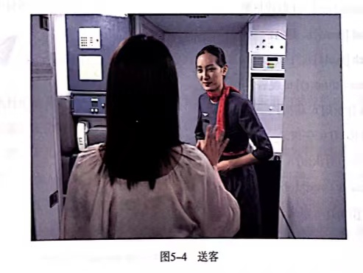
Dialogue G:help passengers disembark^{①}
FA: Thank you for taking this flight. Please remember^{②} to take all your personal belongings^{③} with you. We hope to see you again.
PAX: Thank you. It's very kind of you.
FA: It's my pleasure^{④}. Hope you have a nice journey^{⑤}.
释义：
① disembark [,disim'ba:k] v. 下（车、船、飞机等）
② remember [rɪ'membə(r)] v.记得；记住
③ personal belongings私人物品
④ It's my pleasure 这是我的荣幸；很荣幸；不客气
⑤ journey ['dʒ3:ni] n.旅行；行程

拓展延伸
词语拓展
①breakfast ['brekfəst] n. 早餐
②porridge ['pprid3] n.粥
③Chinese breakfast 中式早餐
④western breakfast 西式早餐
⑤bread [bred] n.面包
⑥lunch [l^ntf] n.午餐
⑦dinner ['dınə(r)] n.晚餐
⑧pork [pɒ:k] n. 猪肉
⑨beef[bi:f]n.牛肉
⑩chicken [ˈtʃɪkɪn] n.鸡肉
⑪vegetable ['vedʒtəbl] n.蔬菜
⑫fruit [fru:t] n.水果
语句拓展
开始供餐服务前，可以提醒旅客调直座椅靠背，以便后面的旅客用餐。
例句：对不起先生，请您调直座椅靠背，以便后面的旅客用餐。
Excuse me, sir. Would you please put your seat back upright so that the lady behind you may be more comfortable while having her meal.
为旅客提供冷饮时，可以询问是否需要加冰块。
例句：请问您的可乐需要加冰吗？
Would you like your coke with ice?
为旅客提供咖啡时，可以询问是否需要加糖和牛奶。
例句：咖啡需要加糖和牛奶吗？
Would you like your coffee with milk and sugar?
旅客下机时若温差较大，或正在下雨，可以在语言上适当提醒旅客。
例句：机舱外温度较为炎热／寒冷，您可以适时减／增衣物。
It is warm/cold outside. You can put off/put on the clothes in times.
外面正在下雨，脚底很滑，下机时请您当心脚下。
It is raining and very slippery outside. Please mind your steps when you disembark.
倾听和练习
请各位同学听录音，自行练习。
飞行测验
你执行的航班遇到气流正在颠簸，作为距离广播器最近的乘务员，赶紧进行广播提示旅客做好安全防护吧。
请根据以下几个情景，分组进行情景演练。然后选出英文发音最标准的一组。
情景一：由A地飞往B地的航班正在登机，你作为该航班的一名乘务员，正在迎客。突然，你发现客舱中有一位外籍旅客好像遇到了问题，快去帮帮她吧。
PAX: Excuse me, Miss. My luggage is too heavy. I can't put it into the overhead compartment by myself. Can you give me a hand?
情景二：由A地飞往B地的航班已经登机结束，在等待起飞。突然，客舱里的一位旅客按响了呼唤铃，作为区域责任乘务员的你快去看看他需要什么帮助吧。
PAX: Excuse me, Miss. May I have a cup of water, please?
情景三：由A地飞往B地的航班正在巡航阶段。厨房乘务员告诉你今天飞机上配备了猪肉面和牛肉饭，饮料的种类有苹果汁、可乐、雪碧、矿泉水、咖啡和茶水，现在让我们一起进行餐饮服务吧。
情景四：由A地飞往B地的航班已经安全落地了，旅客正在下机，但是机外正在下雨，现在让我们一起进行送客服务吧。

